HOLOGRAM CONSTRUCTION

Credits
TsunamiLab was created by José Galaz on 2016 and developed with the help of Cigiden and Inria Chile since then. The hologram was developed at Inria Chile under the “Sin Limites” (unlimited, in spanish) program of the Innovation Center of the Pontifical Catholic University of Chile.

Contributors

Software development. José Galaz, Sebastián Pereira
Hologram device. Natalia Osorio, René Rodríguez, Sebastián Pereira, José Galaz
Design. Grazia Prato, José Galaz, Sebastián Pereira, Natalia Osorio, René Rodríguez

Hologram construction

The hologram is formed to project the image of a screen in a transparent pyramid so that the inclination angle of its faces is of 45° with respect to a horizontal plane (chart 3).

For visualizing the hologram it is necessary to build a holographic pyramid of 4 faces, on which each face has the dimensions specified on chart 1. The pyramid material is a type of uncolored polycarbonate of 1mm thickness, and the ensemble of its faces is made with adhesive crystal tape of 20mm thickness. Each face is cut and joined as is shown in the chart 2.

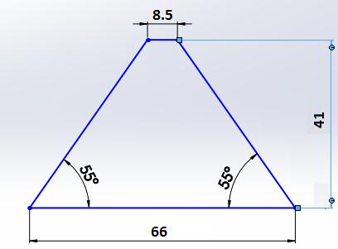
Chart 1. Template for the faces of the pyramid (1 mm thickness). Dimension
are in centimeters.

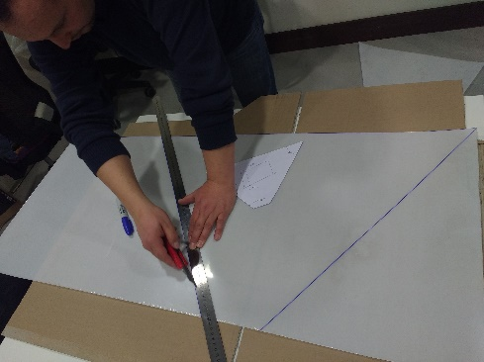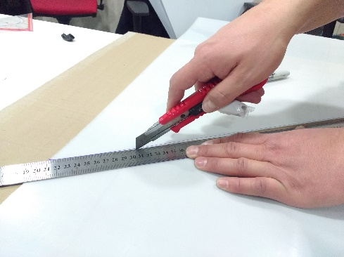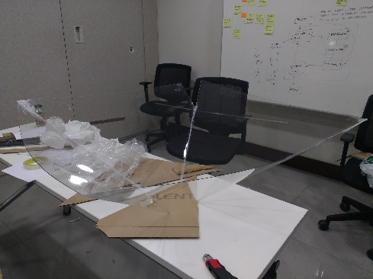
Chart 2. Pyramid construction. Each pyramid face is cut according to the dimensions
of chart 1 and are joined using crystal tape.

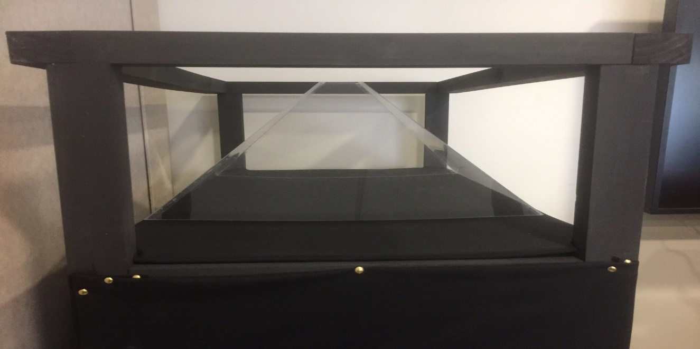
33
45°

Chart 3. Detail of the angle between a face of the pyramid and the horizontal plane.
Distances are in centimeters.

The structure is built in wood, this structure must resist the weight of a 49 inches screen. The vertical distance between the screen and the base of the pyramid (33 cm in Chart 3, for the pyramid in Chart 1.) is the most important for a properly centered holographic projection. A figure showing the construction of the structure is shown in Chart 4.
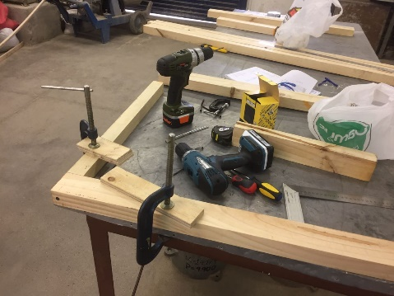
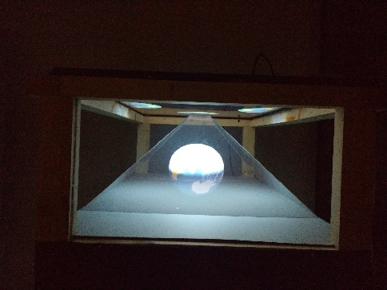
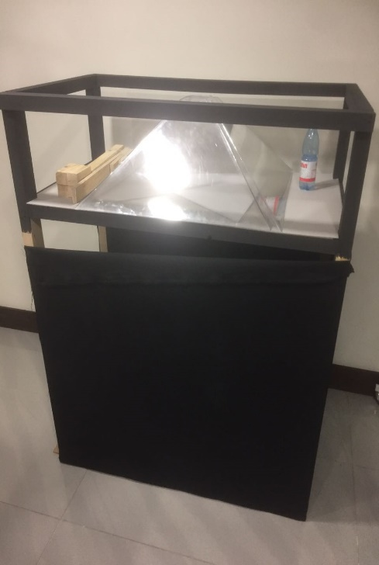
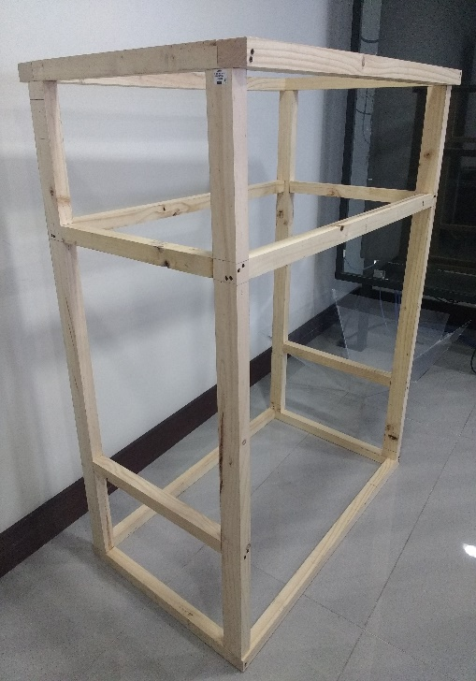
Chart 4. Structure construction.

The structure is ensembled with self-tapping screws. The pieces necessary for the structure construction are presented in table 1, and their corresponding location in the structure is presented in charts 5 and 6.

Table 1: Structure materials

Piece | Name | Number of pieces | Dimension [mm]
1 | Pillar | 4 | 140x4x6.5
2 | Screen support a | 2 | 114x4x6.5
3 | Screen support b | 2 | 60x4x6.5
4 | Pyramid support a | 2 | 106x4x4
5 | Pyramid support b | 4 | 54x4x4
6 | Base a | 2 | 114x4x4
7 | Base b | 2 | 60x4x4
8 | Pyramid base | 1 | 114x67x3
9 | Black fabric base | 1 | 134x87
10 | Black fabric structure | 1 | 400x150

Montage attentions

The pyramid is placed over the “Pyramid base” is shown in Chart 5 (piece 8). The screen is mounted facing down over the structure. It is important to make sure that the pyramid has been centered into the structure, as well as the screen. The pyramid upper side must be located just under the central square of the screen projection (chart 7).

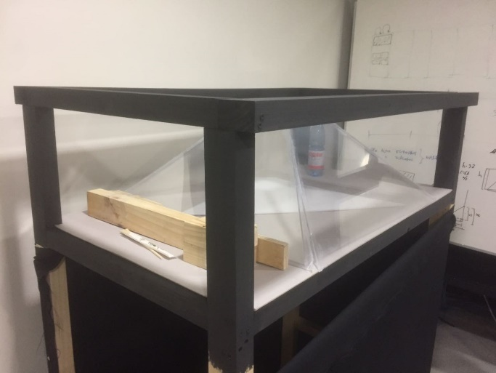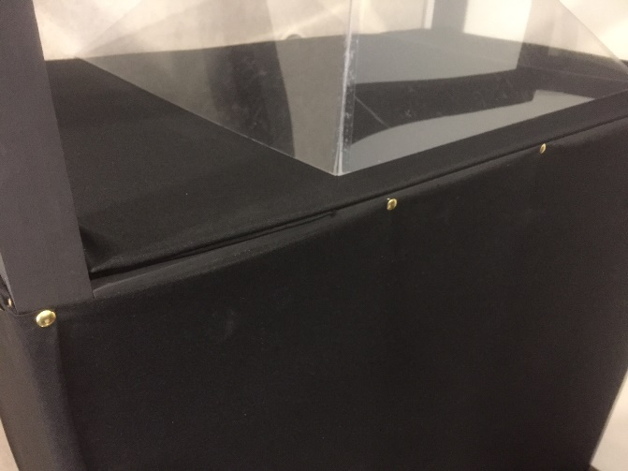
8
9
10

Chart 5. Black fabric detail used in the structure.

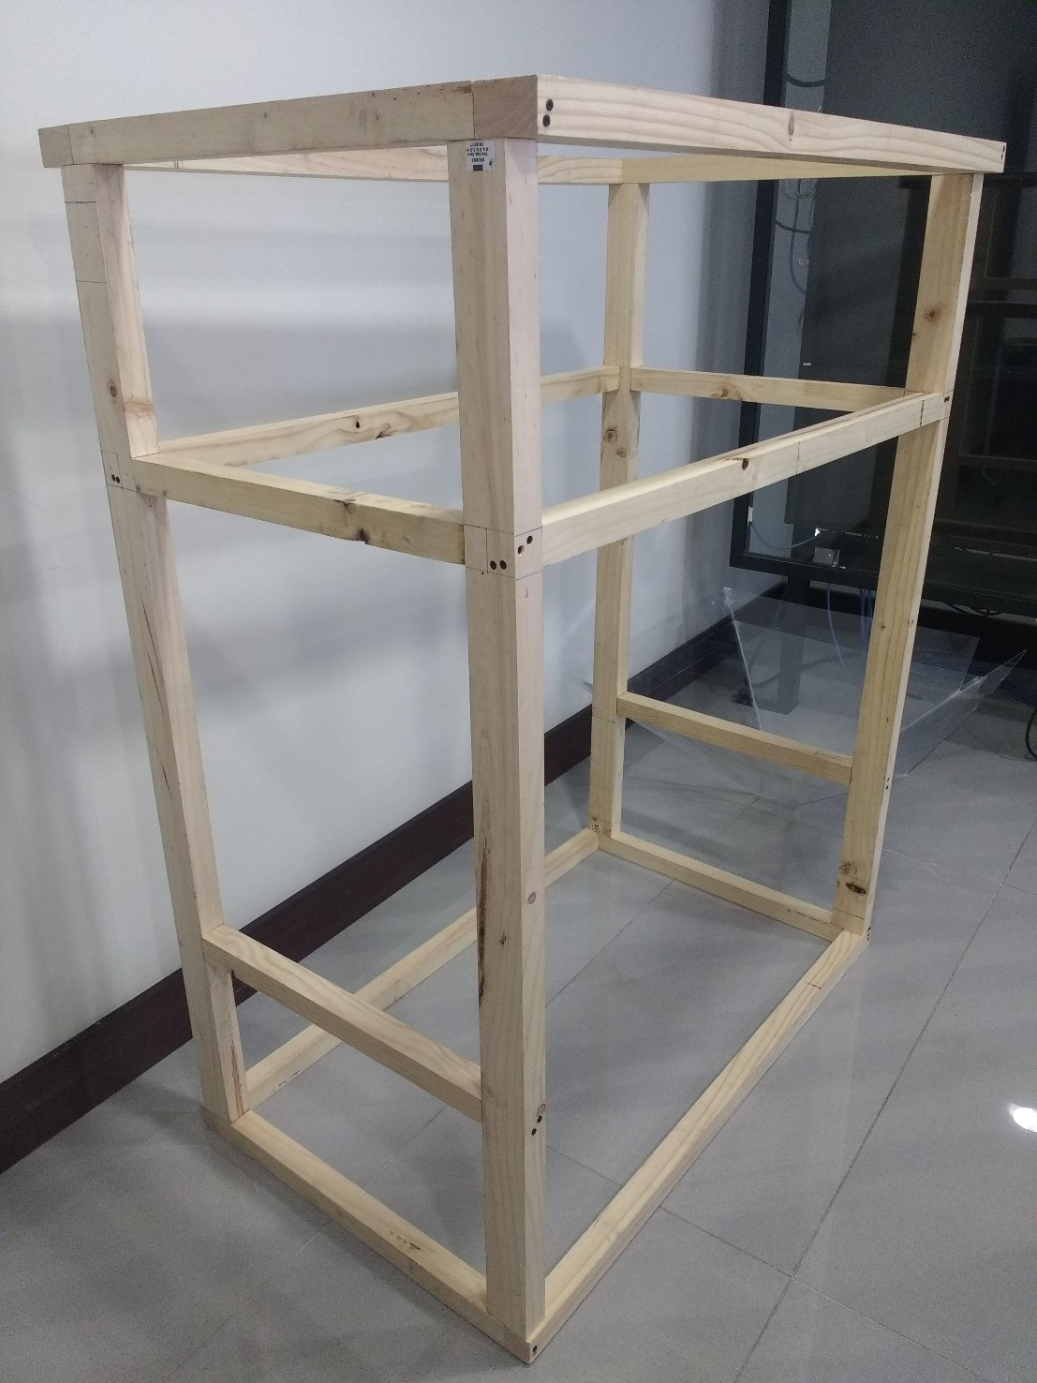
1
2
3
4
5
5
6
7
Chart 6. Wood pieces detail of the structure for its construction.

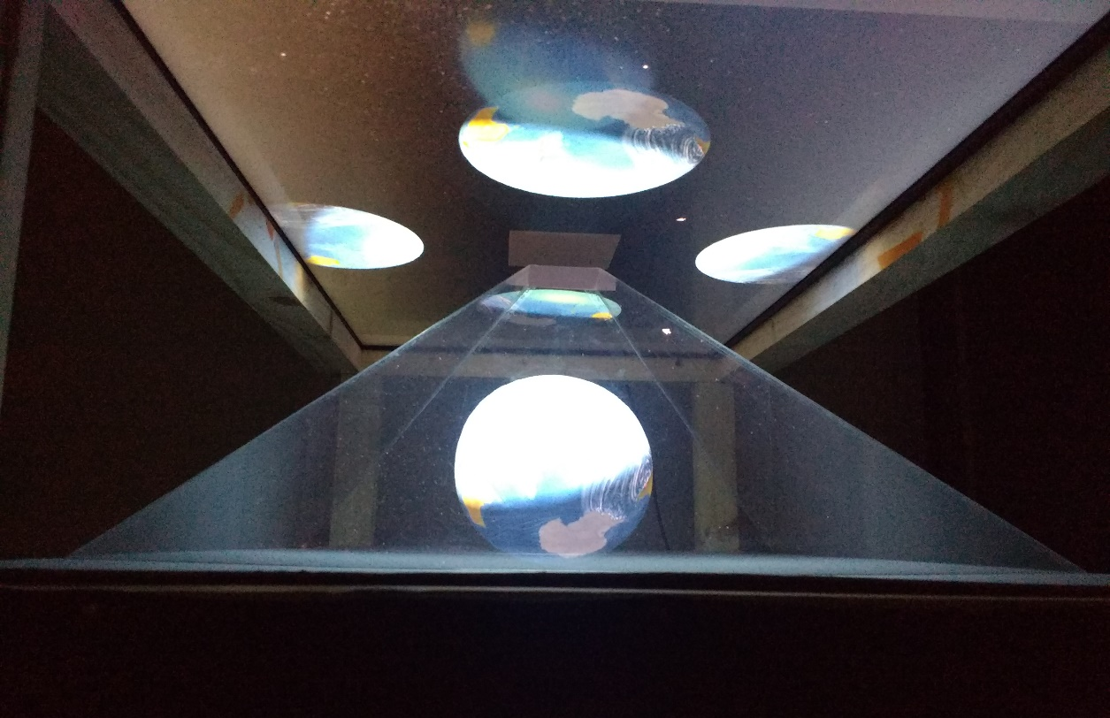

Chart 7. Position of the pyramid and the screen.

